***Screenshots for Patterns***

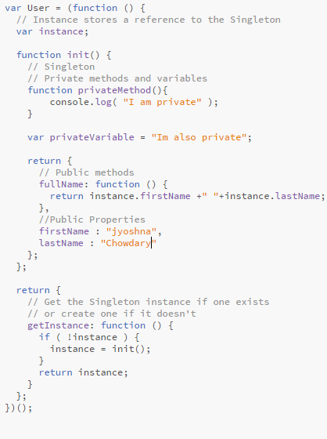

The above screenshot shows the singleton pattern code for register page where the user creates an account in application. The user name is displayed in functionality

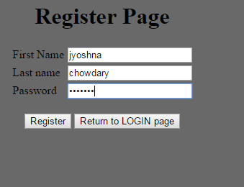

The below screenshot shows the factory pattern for login page where the user logins next time by using the register credentials. Here the user name is displayed in home page

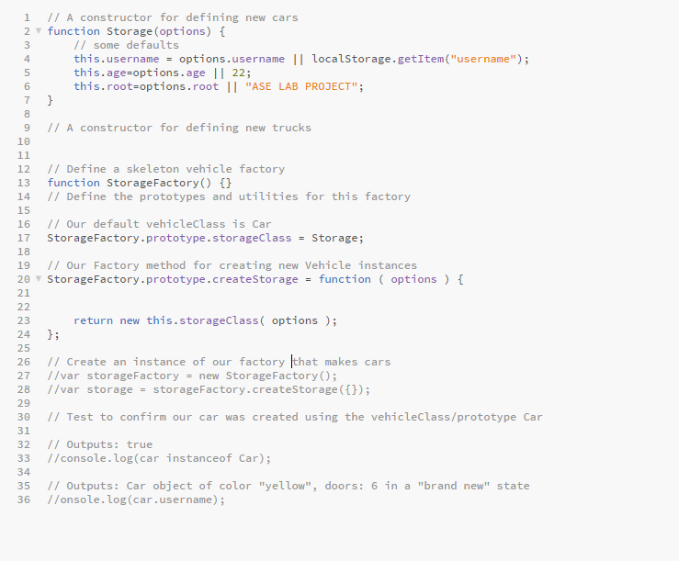

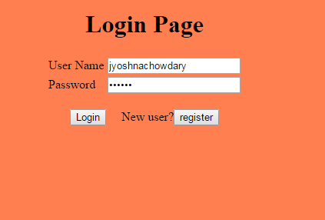

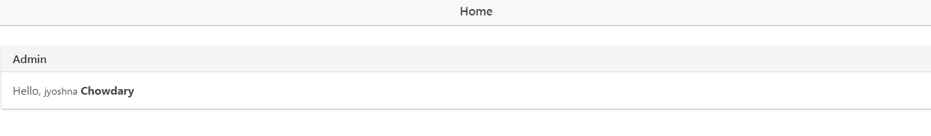

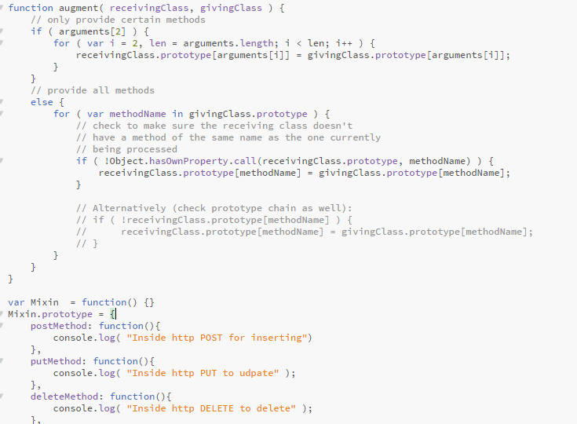

The above shows the Mix in Pattern for the functionality page. Here the logged in user name is shown

